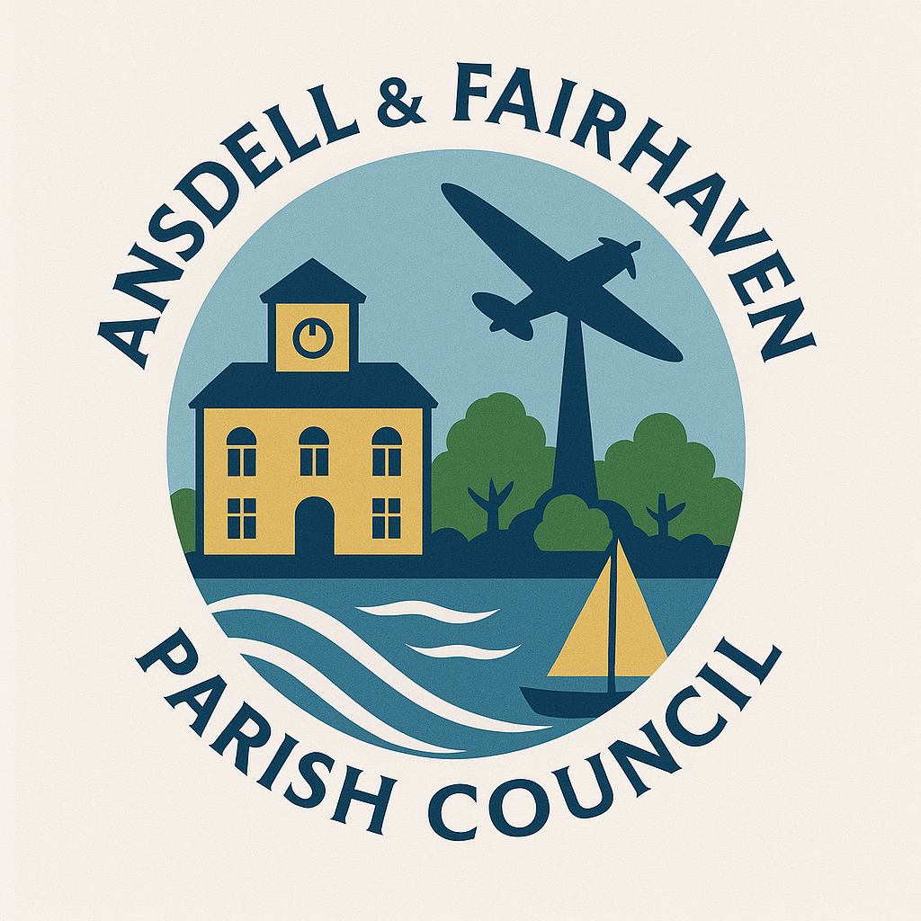
Ansdell & Fairhaven Parish Council
Agenda

You are hereby summoned to attend the meeting of the Community Engagement & Events Committee meeting of Ansdell & Fairhaven Parish Council to be held on Monday 30th June 2025 at 6.30pm at the Ansdell Institute, Lytham St Annes.

Gill Flynn
Interim Clerk

1.Apologies for absence.

2.Declarations of interest and dispensation considerations.

3.To consider the following event proposals for approval at full council:
- Dates & times of events
- Venues
- Costs
- Insurance
- Advertising of events

4.Date and time of next meetings.

Press and public are welcome.

